Agenda: Create basic eCommerce portal with ReactJS.

Sample project deployed git pages url:

<https://vijaykumarsaurav.github.io/sample-ecommerce/#/>

Source Code :

<https://github.com/vijaykumarsaurav/basic-ecommerce.git>

Technologies used: React.js, Material UI, html, css and JavaScript

State Management: React useState, setState and useContext

Demo project description- simple basic ecommerce having below pages.

1. Homepage: categories listing page where category with image should be render
2. Auto complete search box on header
3. Category product listing - on clicking of category show all the product of same.
4. Product detail page – To show all the details about product
5. Action: Add to cart
6. Cart Listing page.

Fake API Used:

<https://fakestoreapi.com/products/>

<https://fakestoreapi.com/products/categories/>

https://fakestoreapi.com/products/category/jewelery

<https://fakestoreapi.com/products/6>

Project folder structure:

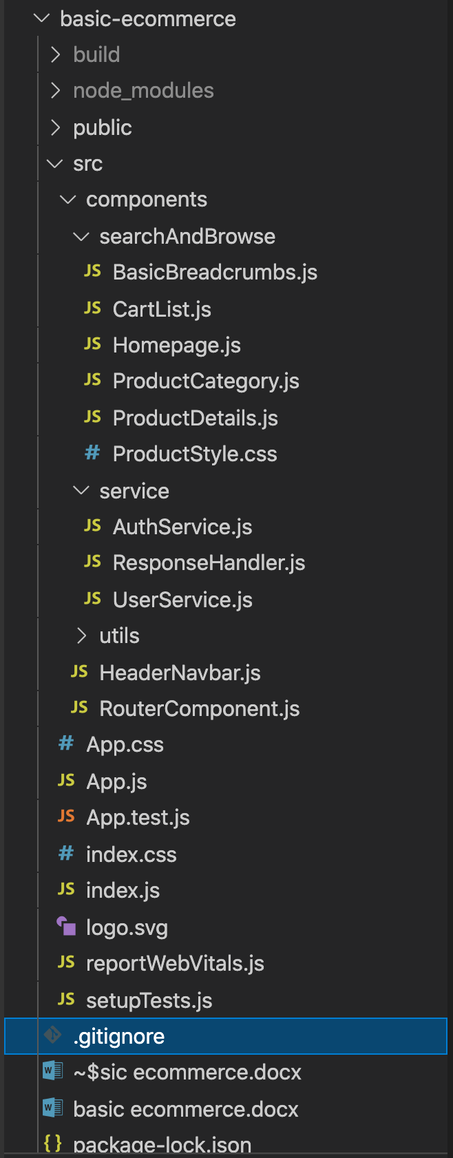

Common components:

1.HeaderNavbar.js – would be available to all page, its contains auto search box and cart icon and User profile.

2. Utility functions can be use in entire application.

RouterComponent.js

import { HashRouter as Router, Route, Switch} from 'react-router-dom'

import React from "react";

import Homepage from './searchAndBrowse/Homepage';

import ProductCategory from './searchAndBrowse/ProductCategory';

import ProductDetails from './searchAndBrowse/ProductDetails';

import CartList from './searchAndBrowse/CartList';

const AppRouter = () => {

return(

<React.Fragment>

<Router>

<Switch>

<Route path="/" exact component={Homepage}/>

<Route path="/product-category" component={ProductCategory}/>

<Route path="/product-details" component={ProductDetails}/>

<Route path="/cart" component={CartList}/>

<Route path="*" component={Homepage} />

</Switch>

</Router>

</React.Fragment>

)

}

export default AppRouter;

Api configuration:

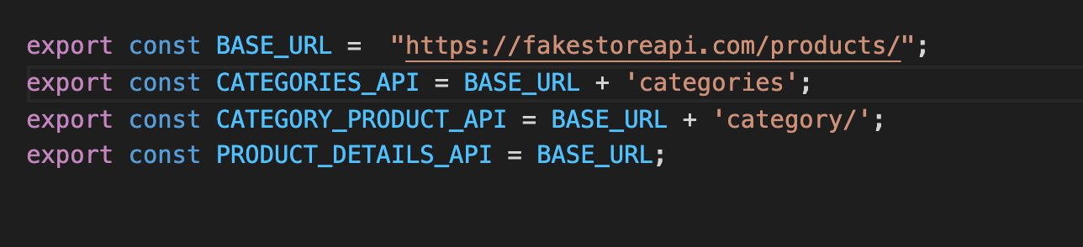

Service api calls:

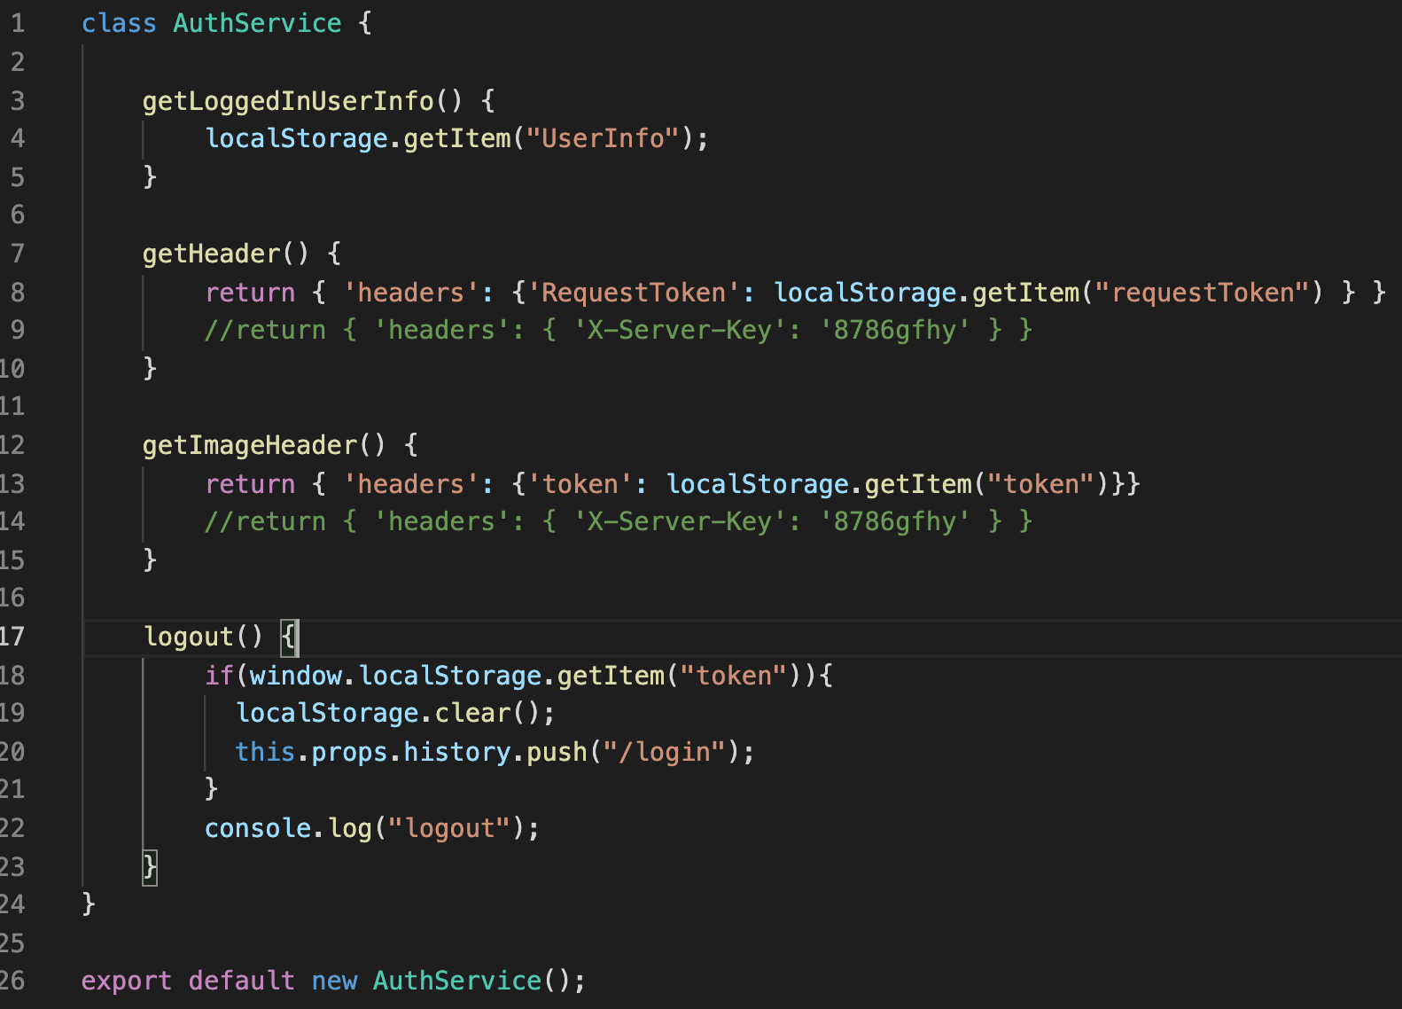

Complete component

import React, { Component } from 'react';

import HeaderNavbar from '../HeaderNavbar'

import UserService from '../service/UserService'

import Grid from '@mui/material/Grid';

import CircularProgress from '@mui/material/CircularProgress';

import { Typography } from '@mui/material';

import Button from '@mui/material/Button';

import { resolveResponse } from "../utils/ResponseHandler";

class Homepage extends Component {

constructor(props) {

super(props);

this.state = {

categoryList: [],

categoryWaitingFlag: true

}

}

componentDidMount() {

UserService.getCategory()

.then((res) => {

// let data = resolveResponse(res); //common response handler

if (res && res.data) {

this.setState({ categoryList: res.data , categoryWaitingFlag:false})

}

});

}

handleClick =(row)=>{

console.log(row)

this.props.history.push('/product-category?q='+row);

}

capitalizeFirstLetter =(string) => {

return string.charAt(0).toUpperCase() + string.slice(1);

}

render() {

return (

<React.Fragment>

<HeaderNavbar history={this.props} />

<Grid direction="row" container spacing={5} style={{ padding: "20px" }}>

<Grid item xs={12} sm={12} >

<Typography variant="h5" component="p" >

Top Categories

</Typography>

</Grid>

{this.state.categoryList && this.state.categoryList.map(row => (

<Grid key={row} item xs={12} sm={3} style={{ textAlign: "center" }}>

<div onClick={()=> this.handleClick(row)} style={{ textAlign: "center", cursor:'pointer' }} >

<img src="https://winaero.com/blog/wp-content/uploads/2019/11/Photos-new-icon.png" /> <br />

{this.capitalizeFirstLetter(row)}

</div>

</Grid>

))}

{this.state.categoryWaitingFlag ? <CircularProgress style={{padding:"25px"}} /> : ""}

</Grid>

<Grid direction="row" container spacing={5} style={{ padding: "20px" }}>

<Grid item xs={12} sm={12} >

<Typography variant="h5" component="p" >

Other Same Categories

</Typography>

</Grid>

{this.state.categoryList && this.state.categoryList.map(row => (

<Grid key={row} item xs={12} sm={3} style={{ textAlign: "center" }}>

<div onClick={()=> this.handleClick(row)} style={{ textAlign: "center", cursor:'pointer' }} >

<img src="https://winaero.com/blog/wp-content/uploads/2019/11/Photos-new-icon.png" /> <br />

{this.capitalizeFirstLetter(row)}

</div>

</Grid>

))}

</Grid>

</React.Fragment>

);

}

}

export default Homepage;

**UI Screenshots:**

Homepage:

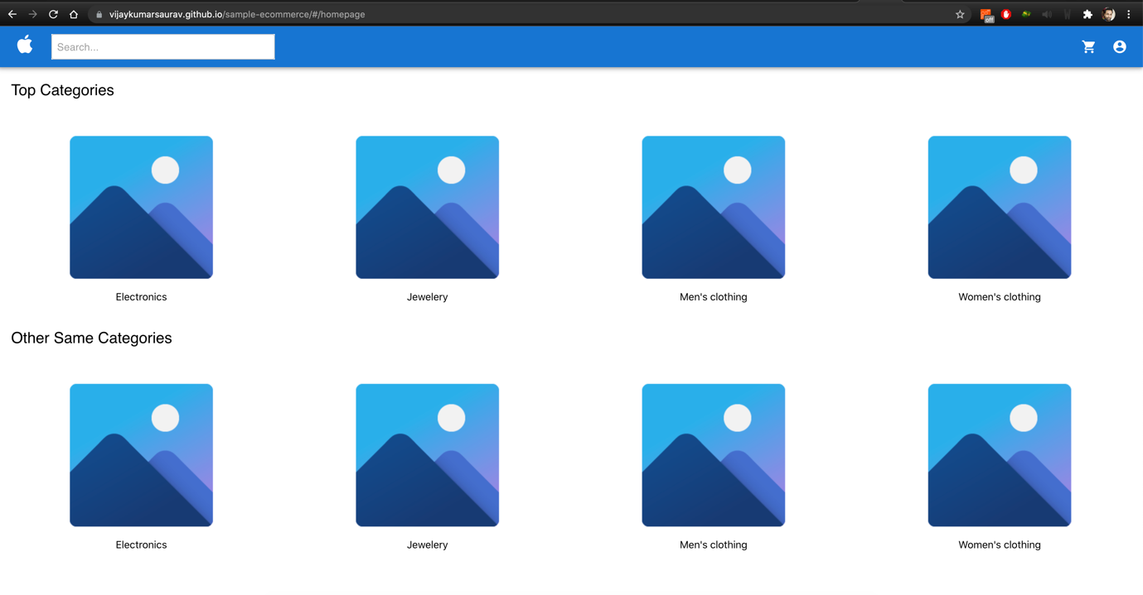

Product category page:

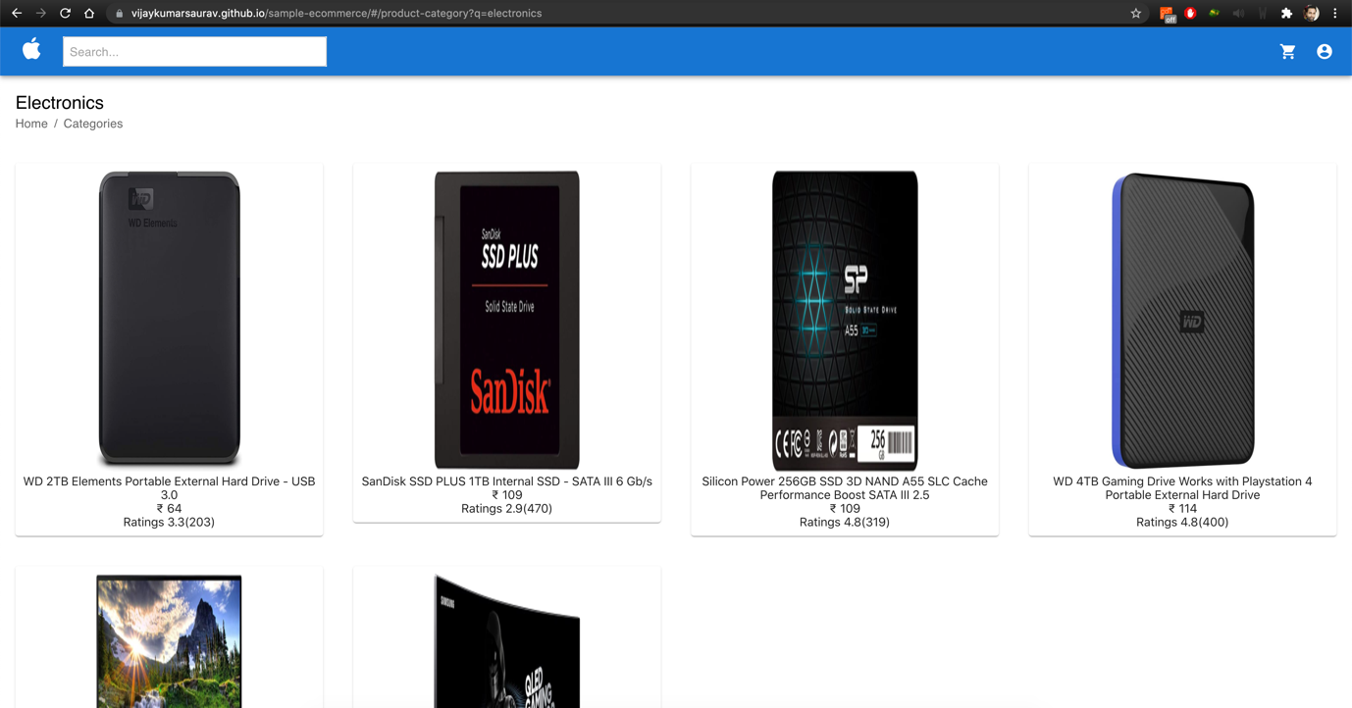

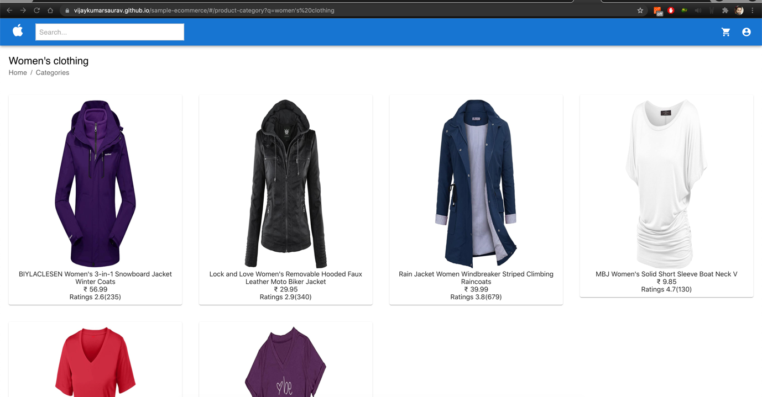

Product Detail page:

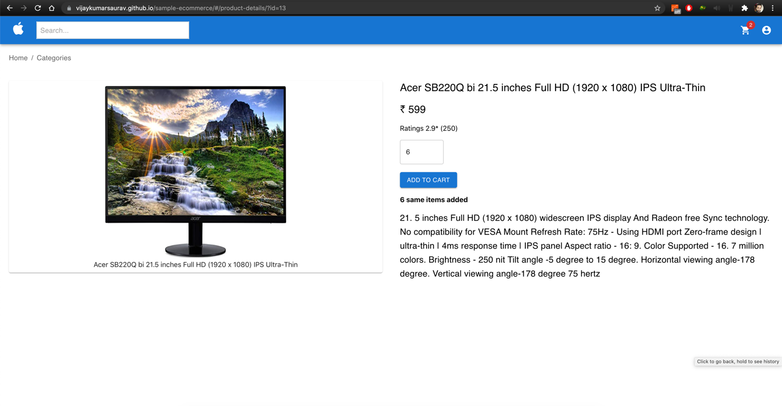

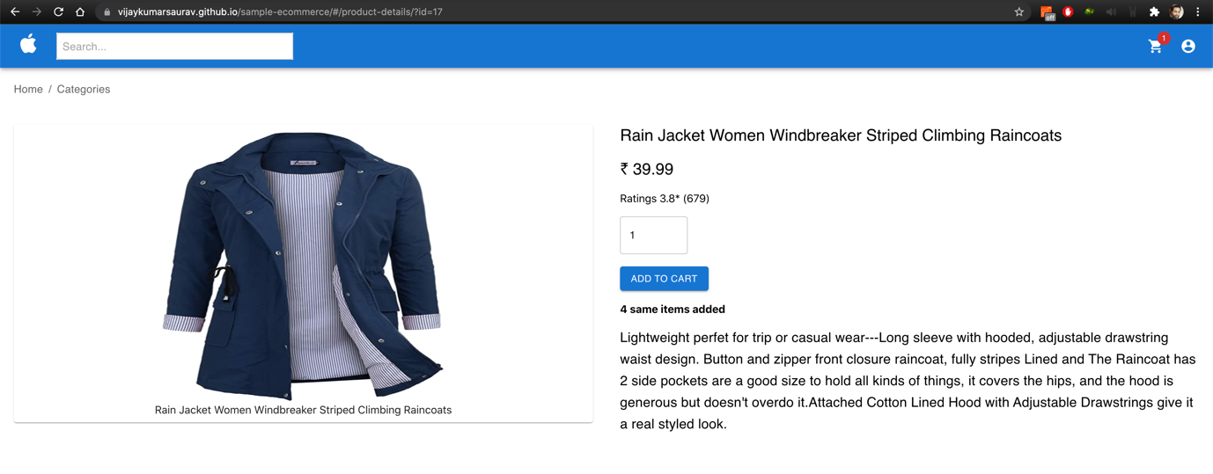

Cart Page:

